LAB EXPERIMENTS
CSA1003 SOFTWARE ENGINEERING
Name : Keerthana.G
Reg no:192521446
Department:IT
JIRA SOFTWARE
EXPERIMENT 12.
You are designing a Task Management System for a small team. The system should include the following features:
1.User Login and Role Assignment
2.Task Creation and Assignment
3.Task Prioritization and Deadlines
4.Progress Tracking and Reporting Prioritize
these requirements using the MoSCoW and Kano models in Jira.

1.Navigate The Scrum Template And Select It

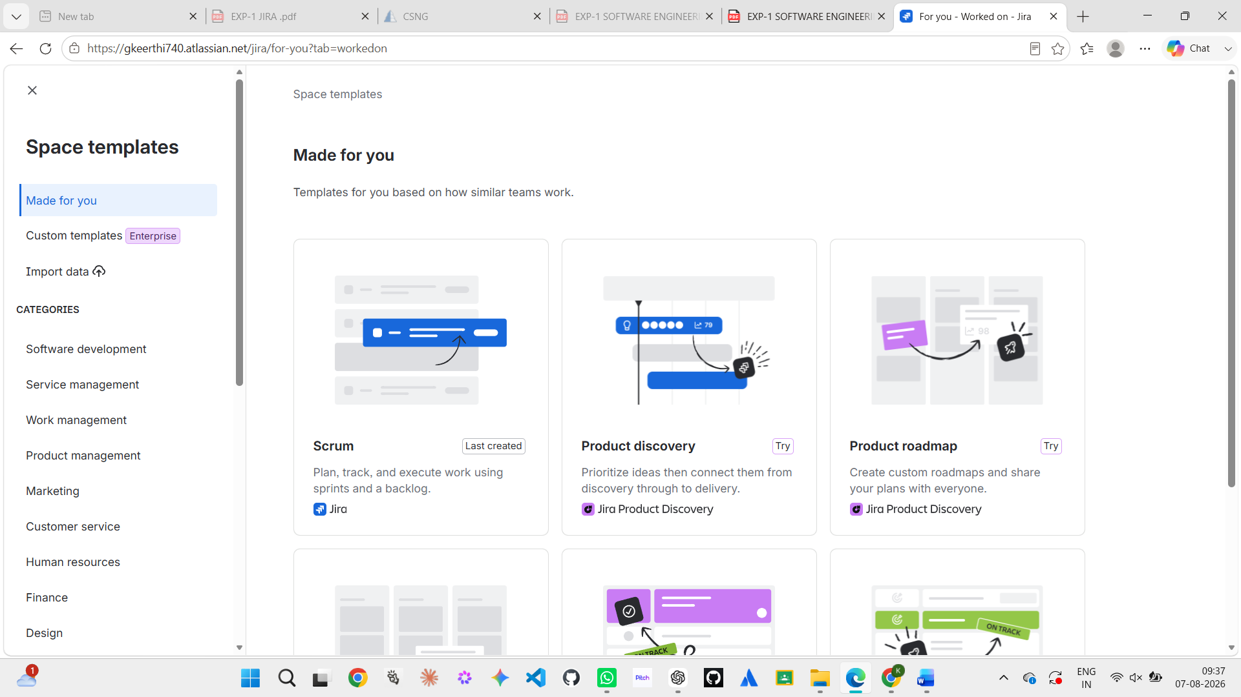

2.Under The Backlog Category Assign All The Work

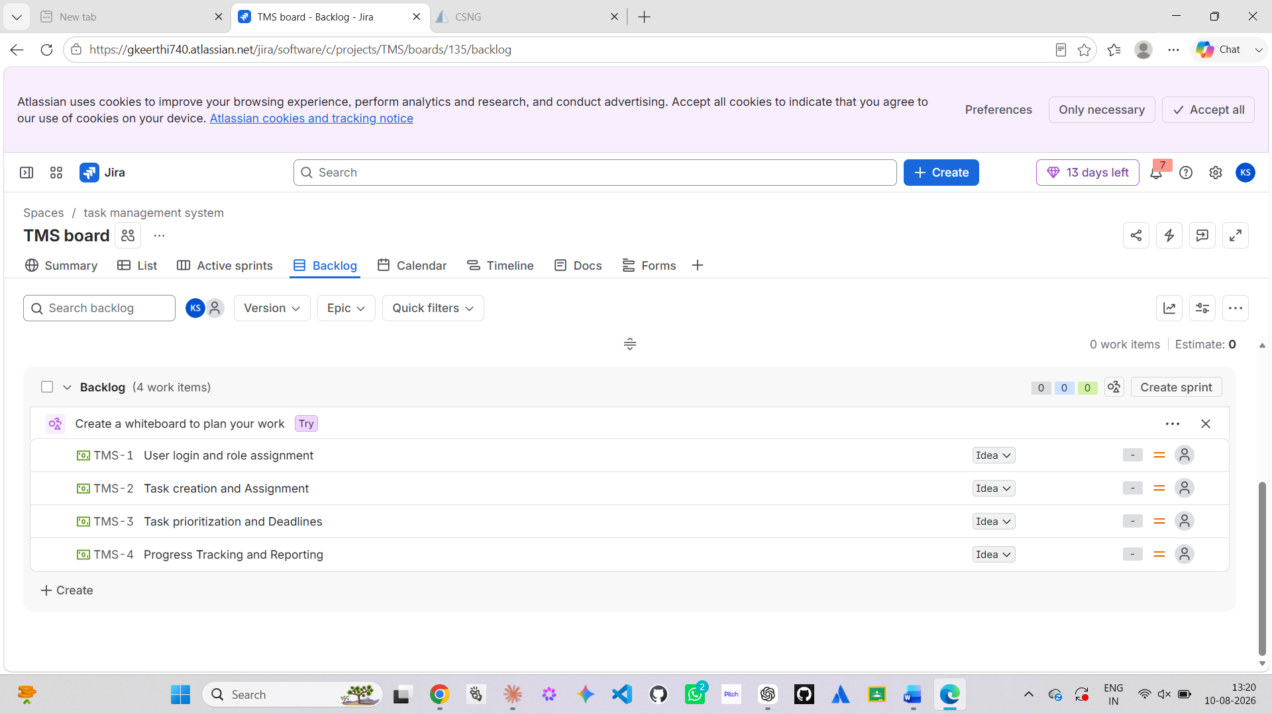

3.Under The The Work Items Catogory There Will The Be A Priority Option Click IT

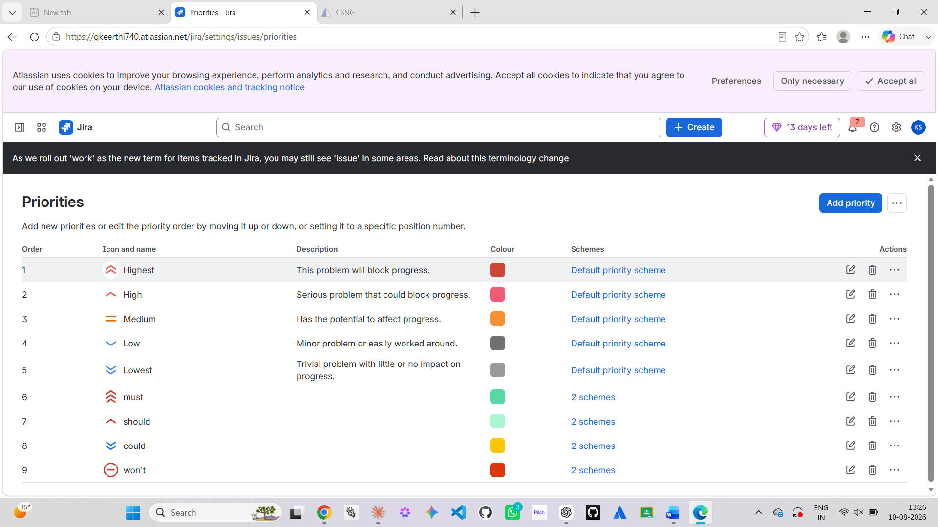

4. Assign The Priority For Each Work

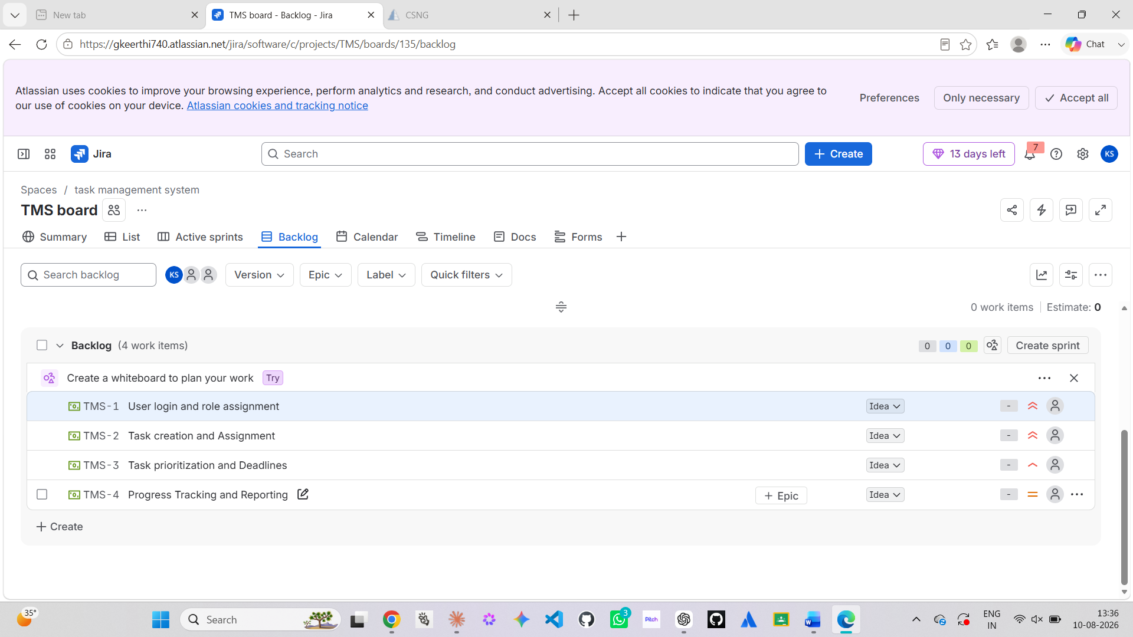

5.Then Assign The Label For Each Work Under The Backlog Catogory

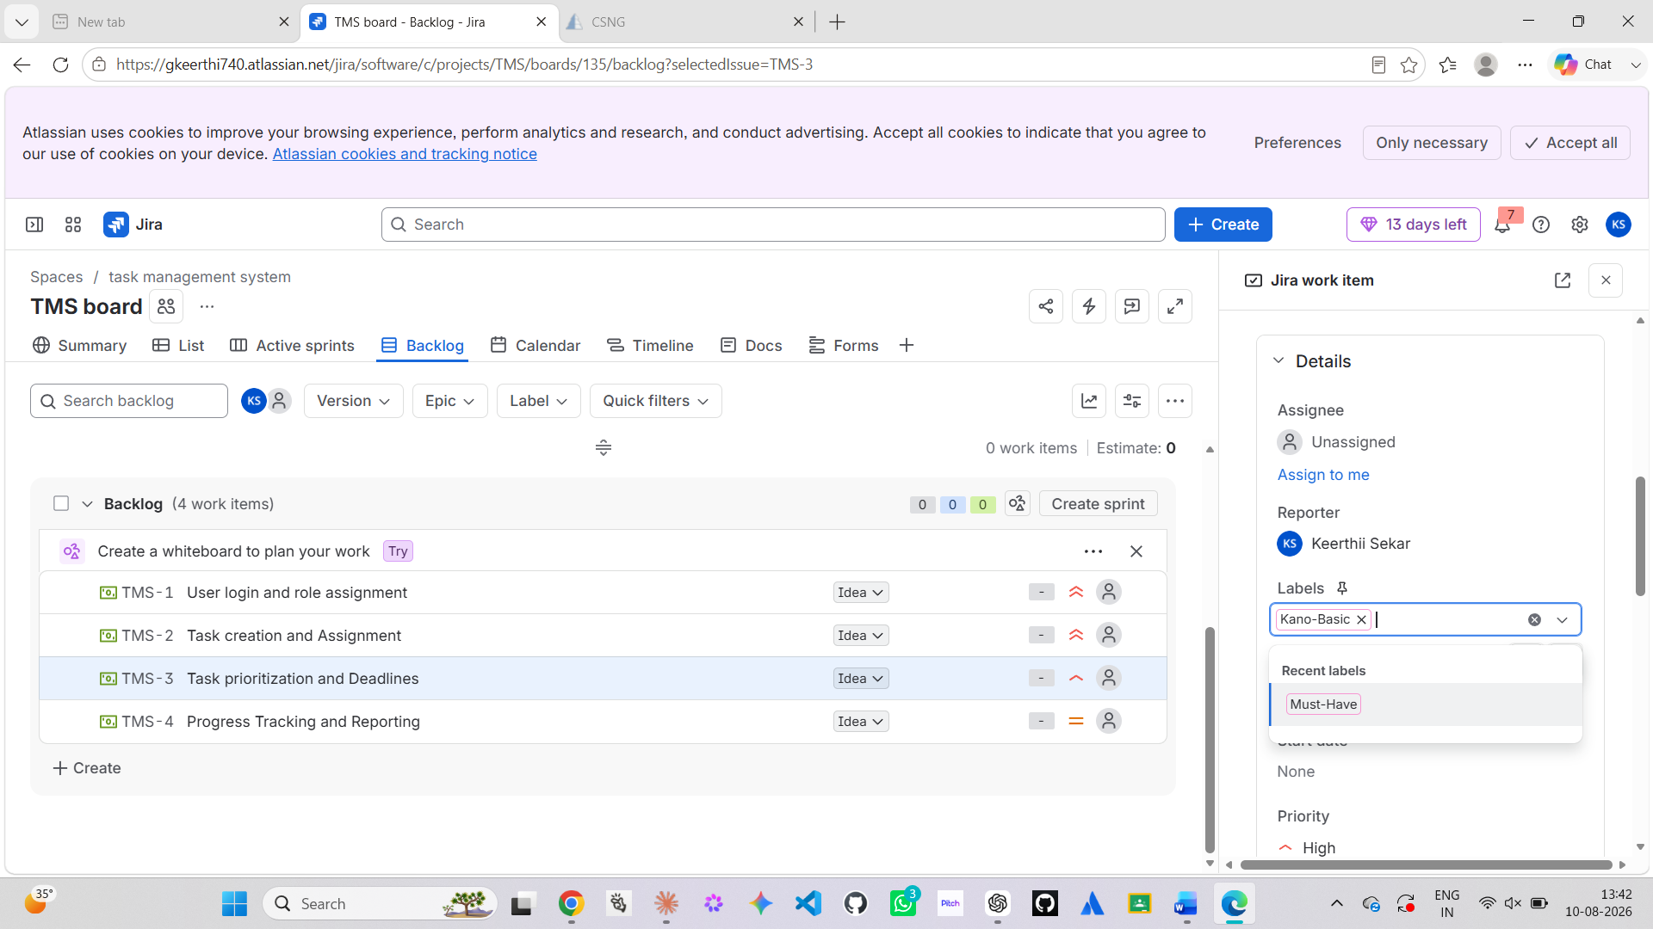

6. Do Thee Same Procedure For The Remaining Tasks

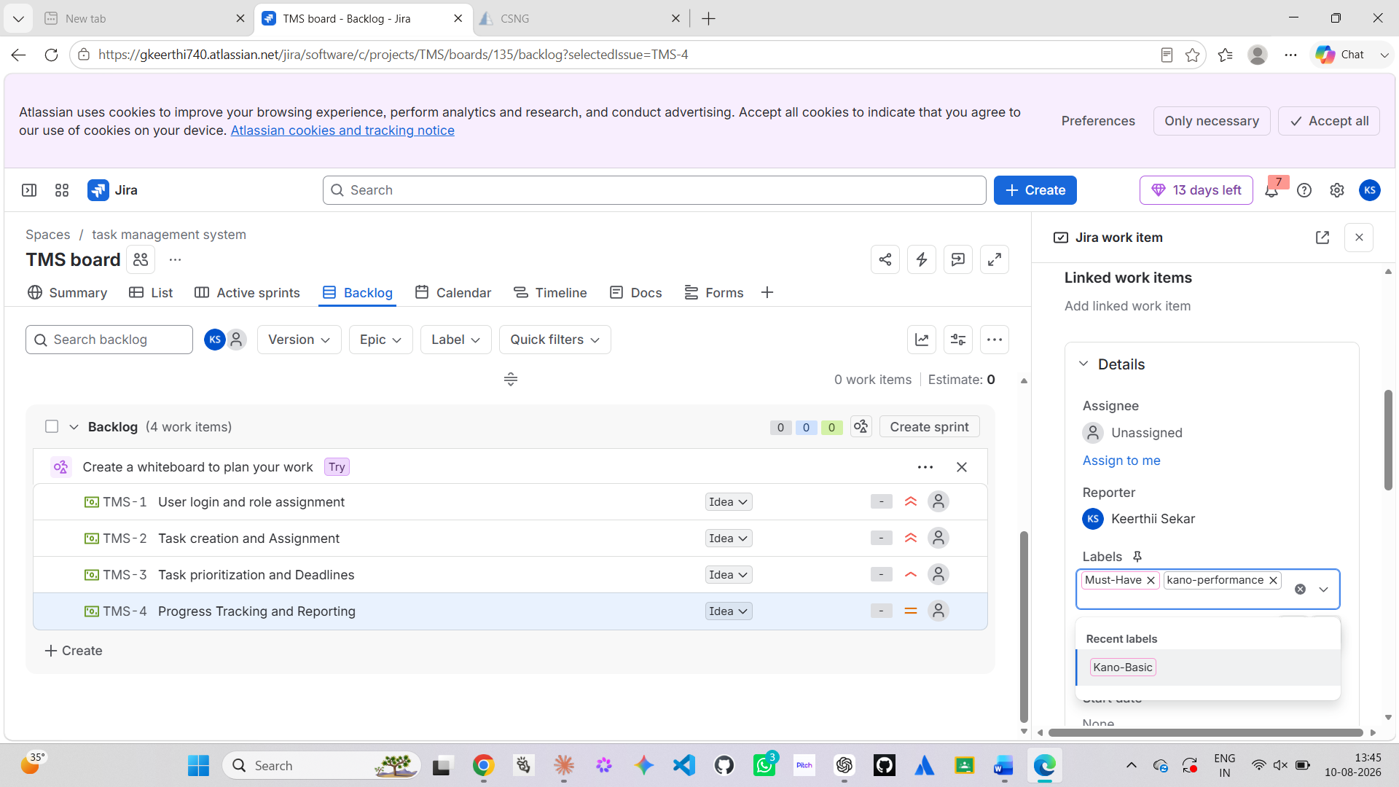

7.The Mascow And The Kano Model Are Created For The Task 1

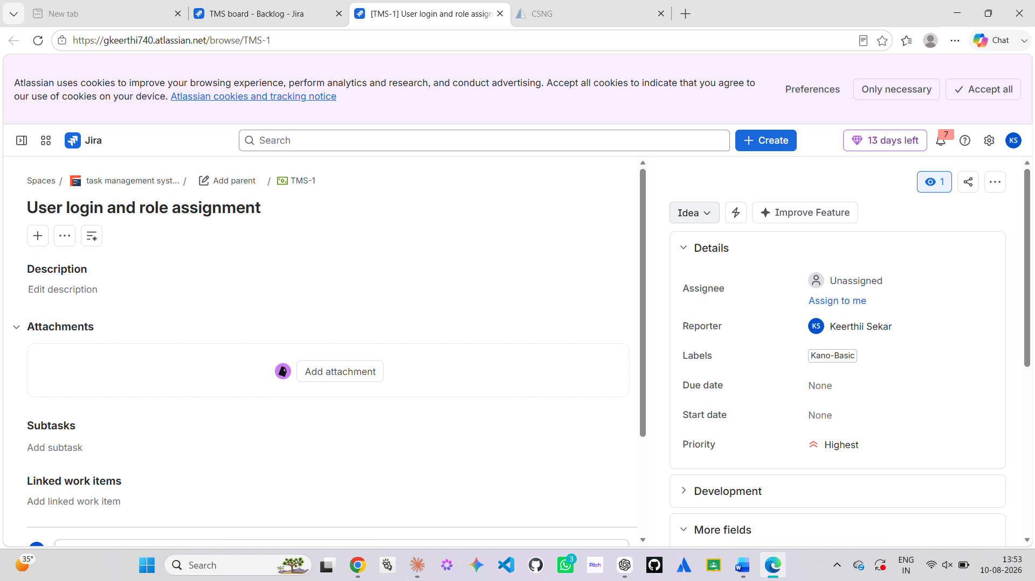

8.The Maskow And The Kano Model Are Created For The Task 2

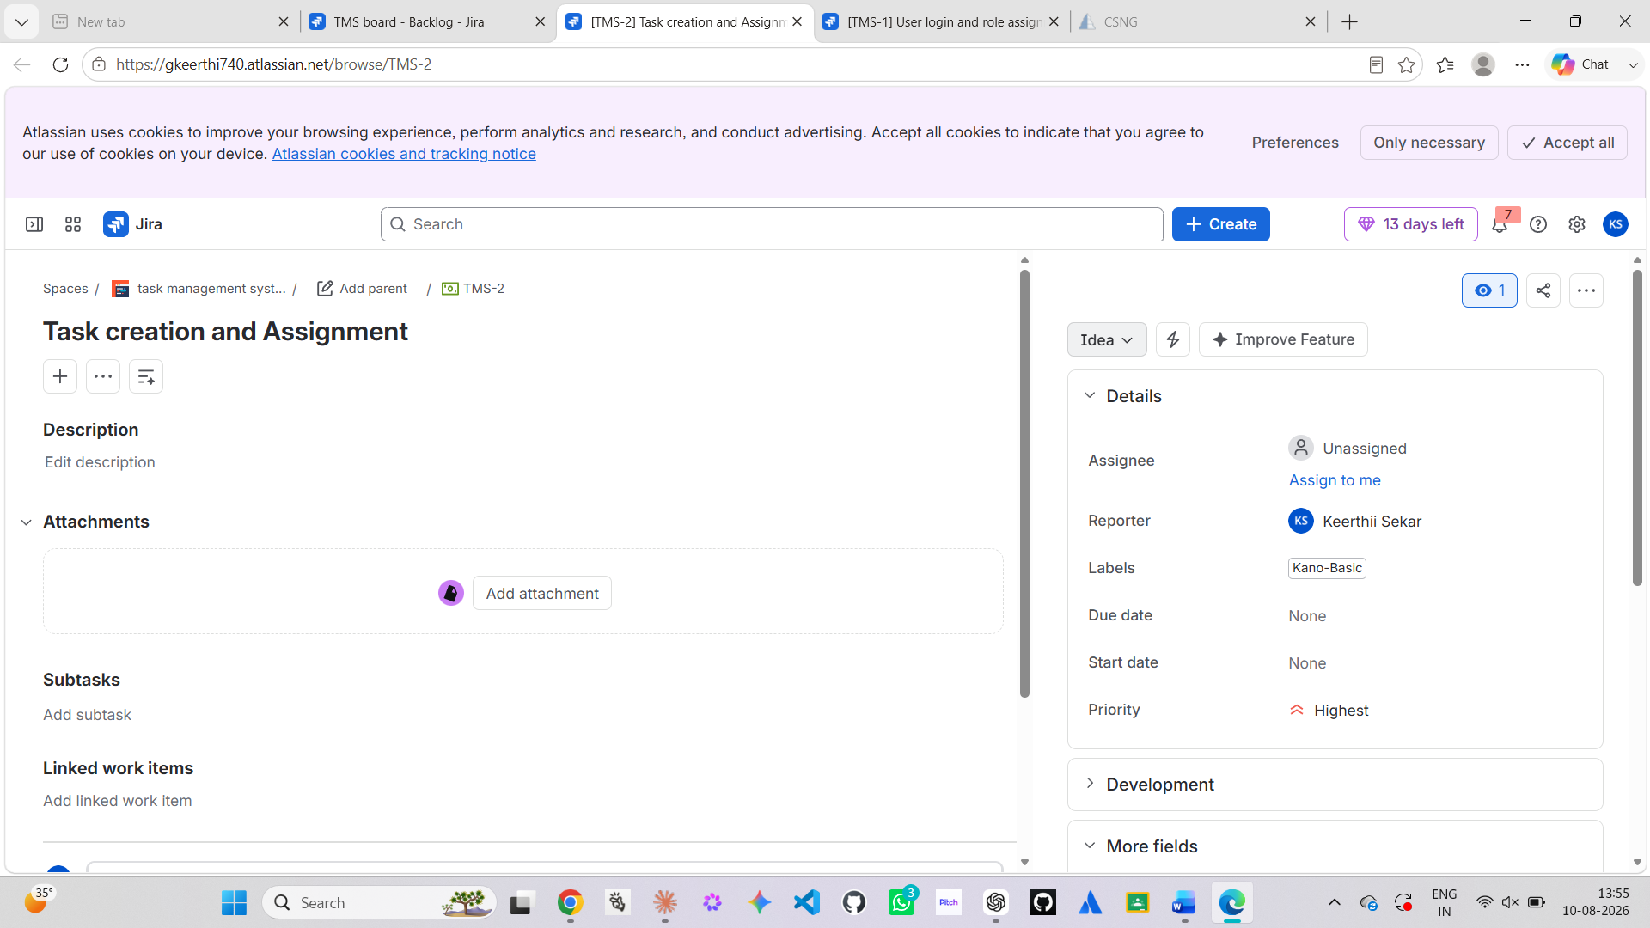

9. The Maskow And The Kano Model Are Created For The Task 3

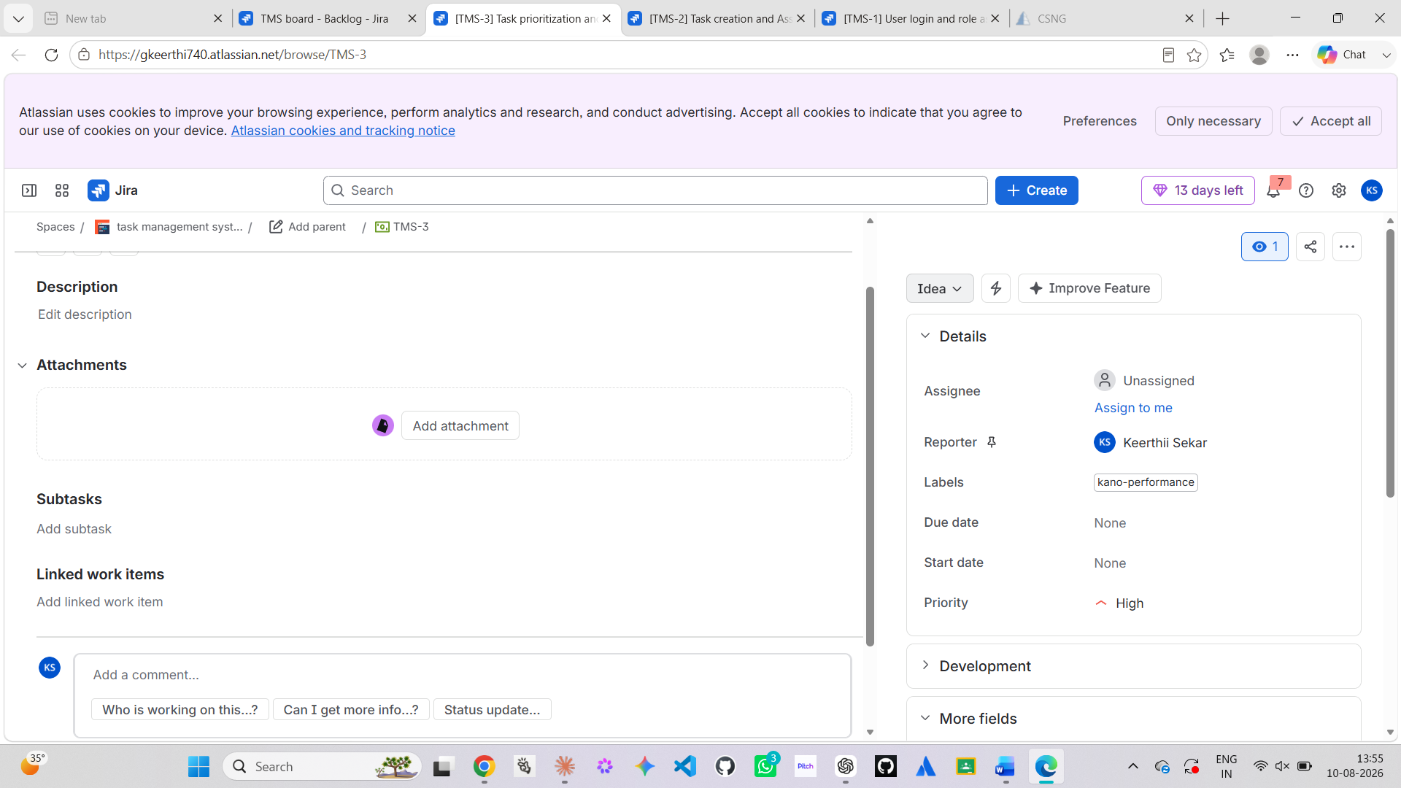

10. The Makow And The Kano Model Are Created For The Task 4

